**Analysis of Alamouti Code and Its Practicality**

**Introduction**

Even as wireless communications become more advanced and more powerful, the goal remains to strive for continuous improvements in transmitting rates while remaining economical. Reliability in transmitting data through diverse environments still remains a challenge due to various obstacles and physical phenomenons. However, many developments, such as Alamouti codes, have helped to lessen the impacts of these obstacles in wireless communications. This paper aims to define and analyze Alamouti codes and investigate the practicality of the schemes.

In order to understand Alamouti codes, there are various terminologies to define to set the context for its importance. Between the receiver and transmitter of a wireless communication system, there is often no direct link due to physical obstacles, and this causes the signal to be reflected in various ways that a distorted signal is received. The channel is often interfered with by Gaussian white noise and relative movements of the transmitter and receiver will also negatively impact the quality of the received signal. The term for this phenomenon is known as multipath fading. As it is difficult to predict this, it is often modelled as time-varying random variables.

Due to the effects of multipath fading, it can be seen that a single input single output (SISO) scheme would not work very efficiently. As there is only one receiver and transmitter, the interference on the signal could cause it to be extremely different from the transmission, meaning data is being lost. Other events could also cause the receiver to not receive the transmission, and the single link between the receiver and transmitter would be lost. Solutions to combat this issue are to increase the number of receivers, called receive diversity, or to increase the number of transmitters, known as transmit diversity. Collectively, increasing either is called antenna diversity, and it establishes multiple links between the transmitter and receiver. As fading alters some of the received signals, the other transmissions will be more clean due to mitigated fading effects, and the transmitted signal can be decoded from these cleaner receptions.

Antenna diversity is the basic principle for multiple input multiple output (MIMO) wireless communication schemes. Within MIMO systems, diversity is achieved with antennas at the transmitter side transmitting the same information but at different time slots. This is known as space-time codes (STCs), which can be further divided into two categories: space-time block codes (STBCs) and space-time trellis codes (STTCs). STTCs have better performance than STBCs, but they are also more complex. Alamouti’s coding schemes are STBCs, so the nuances of the STTCs will not be discussed.

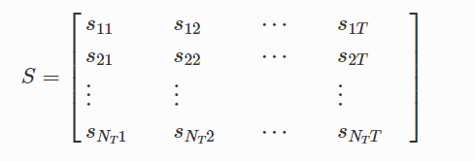

Figure 1. Code matrix representing STBC transmissions over time.

Transmissions of an STBC can be represented with a matrix, shown in the figure above. Each row in the matrix represents an antenna on the transmitter side, with each column representing a time slot. S represents the symbols to which information has been encoded. These matrices are usually designed to have orthogonality so that decoding at the receiver end is simpler, but this sacrifices part of its data rate.

**Alamouti Codes**

The first STBC was Alamouti Codes developed by Siavash Alamouti in 1998. STBCs in MIMO systems are often more complex than the schemes created by Alamouti. The figure below shows the simplicity of an Alamouti scheme through its codeword matrix.

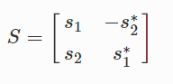

Figure 2. Space-Time Code matrix representing Alamouti codes

This scheme is the only STBC where maximum diversity can be achieved without impacting the data rates.

**Definition:**

Alamouti code was invented by Siavash Alamouti in 1998, in fact, Alamouti code is the simplest of all the STBCs. Here, STBC stands for Space-Time Block Code. Space time block code is now a very commonly used technique in wireless communications. By using STBC, which transmits multiple copies of a data stream across multiple antennas and exploits the various received versions of the data, the reliability of data transmission is improved.

**Introduction of STBC:**

By using space-time block code, the data stream will be encoded in blocks before transmission. Basically, the data are distributed to 2 dimensions which are different transmit antennas and different time slots. We can draw a scheme just like the picture below:

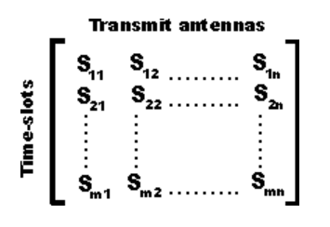

(Adapted from <https://www.electronics-notes.com/articles/antennas-propagation/mimo/space-time-block-alamouti-codes-coding.php>)

As an example, $S_{23}$ would be the data stream that being transmitted in time slot 2 from antenna 3.

**Basic structure of Alamouti code:**

For Alamouti’s code, it was designed for a two-transmit antenna system.

It has the coding matrix displayed below:

$C_{2}= \left[\begin{matrix}C_{1} & C_{2} \\ -{C_{2}}^{*} & {C_{1}}^{*}\end{matrix}\right]$

(* denotes to complex conjugate.)

The space-time diversity can be presented with the diagram below:

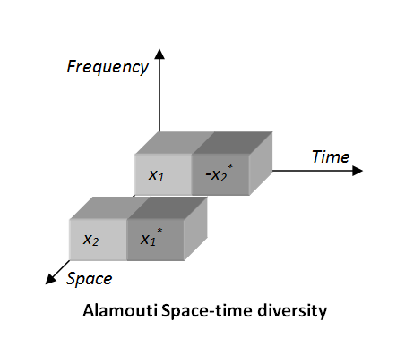

(Adapted from <http://www.nutaq.com/blog/alamouti-space-time-block-coding>)

**How it works:**

Because in Alamouti code, two antennas are used on each transmitter side and receiver side, transmitter will send two OFDM symbols and their conjugate during two time slots. During it is being transmitting through the channel, both signals would suffer from channel fading. After the signals are received, their sum will be received.

Since the transmission is done over two periods of time, at the receiver side, it will also get decoded over two periods of time, the vector Y which represented the received signal can be written by the equation below:

$$Y=\left[\begin{matrix}{y_{1}}^{1} \\ {y_{2}}^{1}\end{matrix}\right]= \left[\begin{matrix}h_{11} & h_{12} \\ h_{21} & h_{22}\end{matrix}\right] \left[\begin{matrix}x_{1} \\ x_{2}\end{matrix}\right]+\left[\begin{matrix}{n_{1}}^{1} \\ {n_{2}}^{1}\end{matrix}\right]$$

(First time period)

$$Y=\left[\begin{matrix}{y_{1}}^{2} \\ {y_{2}}^{2}\end{matrix}\right]= \left[\begin{matrix}h_{11} & h_{12} \\ h_{21} & h_{22}\end{matrix}\right] \left[\begin{matrix}{{-x}_{2}}^{*} \\ {x_{1}}^{*}\end{matrix}\right]+\left[\begin{matrix}{n_{1}}^{2} \\ {n_{2}}^{2}\end{matrix}\right]$$

(Second time period)

$\left[\begin{matrix}{y_{1}}^{1} \\ {y_{2}}^{1}\end{matrix}\right]$: the received OFDM symbol at the first time period.

$\left[\begin{matrix}{y_{1}}^{2} \\ {y_{2}}^{2}\end{matrix}\right]$: the received OFDM symbol at the second time period.

If we combine Y1 and Y2, we will have the equation below:

$$Y=\left[\begin{matrix}\begin{matrix}{y_{1}}^{1} \\ \begin{matrix}{y_{2}}^{1} \\ {y_{1}}^{2}\end{matrix}\end{matrix} \\ {y_{2}}^{2}\end{matrix}\right]=\left[\begin{matrix}\begin{matrix}h_{11} & h_{12} \\ h_{21} & h_{22}\end{matrix} \\ \begin{matrix}{h_{12}}^{*} & {h_{11}}^{*} \\ {h_{22}}^{*} & {h_{21}}^{*}\end{matrix}\end{matrix}\right] \left[\begin{matrix}x_{1} \\ x_{2}\end{matrix}\right]+\left[\begin{matrix}\begin{matrix}{n_{1}}^{1} \\ \begin{matrix}{n_{2}}^{1} \\ {n_{1}}^{2*}\end{matrix}\end{matrix} \\ {n_{2}}^{2*}\end{matrix}\right]$$

After we have the combination, we need to isolate the symbols to x1 and x2.

We can isolate x1 and x2 by simply multiplying the matrix Y by the inverse of H which is:

$$H= \left[\begin{matrix}\begin{matrix}h_{11} & h_{12} \\ h_{21} & h_{22}\end{matrix} \\ \begin{matrix}{h_{12}}^{*} & -{h_{11}}^{*} \\ {h_{22}}^{*} & {{-h}_{21}}^{*}\end{matrix}\end{matrix}\right]$$

**Difference between single antenna system:**

1. Diversity

MIMO (Multi-input Multi-output) technology can have both transmitter side and receiver side has multiple antenna so transmitter can send multiple same data streams and receiver can hear multiple same signals, which improves the reliability of the data transmitting system.

1. Spatial multiplexing

By using spatial-multiplexing technique, many different data streams can be transmitted at the same time and that achieves a higher transmitting rate.

**Advantage of Alamouti code:**

**Disadvantage of Alamouti code:**

**Application of Alamouti code:**

The fact that the transmitted signal must traverse a potentially difficult environment with scattering, reflection, refraction and so on and may then be further corrupted by thermal noise in the receiver means that some of the received copies of the data may be closer to the original signal than others. This redundancy results in a higher chance of being able to use one or more of the received copies to correctly decode the received signal. In fact, space–time coding combines all the copies of the received signal in an optimal way to extract as much information from each of them as possible.

**Combination schemes**

**Cyclic prefix**

-Explain What alamouti codes are (Shuihan, Mohamed)   - Next two sections ~ 2.5 - 3 pages

-Combination schemes (Shuihan, Mohamed)

**References:**

Space-Time block code

<https://en.wikipedia.org/wiki/Space%E2%80%93time_block_code#Alamouti's_code>

MIMO Space Time Block Coding and Alamouti Codes

<https://www.electronics-notes.com/articles/antennas-propagation/mimo/space-time-block-alamouti-codes-coding.php>

(1) <https://link.springer.com/chapter/10.1007/978-981-15-0561-4_12>

(2) <https://onlinelibrary.wiley.com/doi/pdf/10.1002/9781119331797.app2>

(3) Alamouti’s Paper

(4) <https://faculty.coe.drexel.edu/jwalsh/Jiespacetimecodes.pdf>